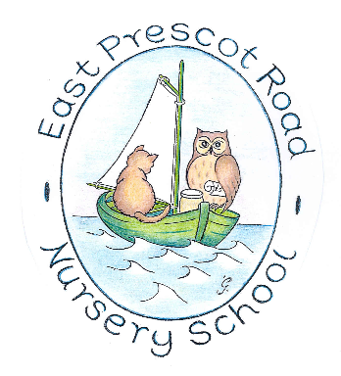

Promoting British Values at East Prescot Road Nursery School

What are Fundamental British Values?
British Values were first introduced in schools in 2014 when the Department for Education stated the purpose was “to create and enforce a clear and rigorous expectation on all schools to promote the fundamental British values of democracy, the rule of law, individual liberty, mutual respect and tolerance of those with different faiths and beliefs”. British Values represent everyone in our multicultural society, including every race, ethnicity and every gender variation.

The philosophy behind the teaching of British Values is to:
- Encourage respect for other people
- Promote further tolerance and harmony between different cultural traditions by enabling children to acquire an appreciation for and respect for their own and other cultures
- Enable our children to develop their self-knowledge, self-esteem, and self-confidence
- Encourage our children to accept responsibility for their behaviour, show initiative and understand how they can contribute positively to the lives of those living and working in the locality of school and to society more widely
- Enable children to distinguish right from wrong and to respect the civil and criminal law of England
- Encourage respect for democracy and support for participation in the democratic processes, including to respect the civil and criminal law of England
- Enable children to acquire a broad general knowledge of and respect for public institutions and services in England
- Promote community cohesion.

How does our school promote Fundamental British Values?
We take seriously our responsibility to prepare children for life in modern Britain. We ensure that the fundamental British Values are introduced, discussed and lived out through the ethos and work of our school.
Our school mission, values, vision and ethos embody all the fundamental British Values and are at the core of all our work with our children.
Our aim is to place the success of every child at the centre of all our decision-making. We strive to inspire our children to have a lifelong love of learning; grow in confidence and value themselves and others. We support our children to be the best they can be, enabling them to achieve through a wonderfully wide and challenging curriculum.

How do we share our learning?
Our display in the Foyer showcases the children’s experiences and learning about British Values over the year. We also have a display that promotes our school’s ‘Friendship and Trust’ Values that underpin the work we do in school to support our children to grow into responsible citizens in a modern, multicultural society.



The British Values are:
- democracy
- the rule of law
- individual liberty
- mutual respect
- tolerance of those with different faiths and beliefs

British Values fit under the wider umbrella of the Spiritual, Moral, Social and Cultural Development (SMSC)

Many areas of the curriculum also provide opportunities to promote these values in a planned and structured way. In particular, Personal, Social and Health Education (PSHE) supports the direct teaching of British Values and provide excellent opportunities to deepen and develop understanding. Our school Curriculum Matrix outlines how skills, knowledge and understanding are taught sequentially and progressively over the school year.

We engage in practical voting led by our school council and develop an understanding and knowledge of how Parliament works and the democracy of law.

Approved: October 2023
Review: October 2026

